|  |
| --- |
| REPORT |
| 1st Homework |

|  |  |
| --- | --- |
| Subject | Computational Microelectronics |
| Professor | 홍 성 민 |
| Name | 조 성 훈 |
| Student Number | 20162071 |
| Due Date | 2018/09/09 - 8AM |



Below simulations is done using MATLAB.

This report shows the calculated potential ground which is dependent on the number of point (analysis resolution) and shows the error-rate between present point and steady-state point of 1000.

<Assumption>

Potential well length is 5nm. The quantization point varies from 5 to 2500, and the 2500th point can reach the steady-state of potential ground.

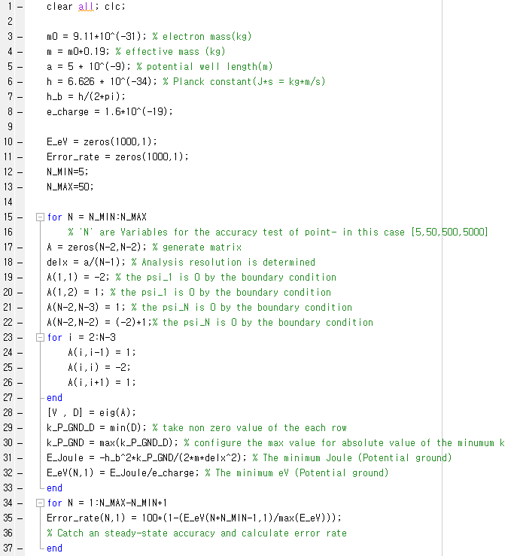

<The potential ground at different point>

|  |  |  |  |  |
| --- | --- | --- | --- | --- |
| # of point | 5 | 50 | 500 | 2500 |
| eV | 0.0753 | 0.0792 | 0.0793 | 0.0793 |

<Error rate for confirmation of the steady-state>



<Error-rate>



<Error-rate (log scale x-axis)>

By this graph, the larger number of point is required for the accurate simulation result. The simulation accuracy is dependent on the number of point (resolution).

So if we want to more accurate simulation in 1-dimensinal schrodinger equation.